Isaac Ray Shoebottom

CS 1073 (FR02A)

Assignment 9

3429069

# Section A

## Source Code (GPACalculator):

import javafx.application.Application;

import javafx.event.ActionEvent;

import javafx.geometry.Insets;

import javafx.geometry.Pos;

import javafx.scene.Scene;

import javafx.scene.control.Button;

import javafx.scene.control.TextField;

import javafx.scene.layout.FlowPane;

import javafx.scene.text.Text;

import javafx.stage.Stage;

import java.text.DecimalFormat;

public class GPACalculator extends Application {

FlowPane flowPane = new FlowPane();

Text textPointsForCourse = new Text("Welcome to my GPA Calculator!");

Text textCumulativeGPA = new Text("Enter your 1ˢᵗ grade and credit hrs.");

TextField textFieldCLG = new TextField("");

TextField textFieldCCH = new TextField("");

Text textCLG = new Text("Course letter grade:");

Text textCCH = new Text("Course Credit hours:");

Button buttonAddGPA = new Button("Add to GPA");

Button buttonClearGPA = new Button("Clear GPA");

double GPA;

double totalCreditHours;

double totalGradePoints;

public static void main(String[] args) {

launch(args);

}

@Override

public void start(Stage primaryStage) {

primaryStage.setTitle("GPA Calculator");

flowPane.setPadding(new Insets(10, 10, 10, 10));

flowPane.setHgap(10);

flowPane.setVgap(10);

flowPane.setAlignment(Pos.CENTER);

buttonAddGPA.setOnAction(this::AddGPA);

buttonClearGPA.setOnAction(this::ClearGPA);

textFieldCCH.setPrefWidth(50);

textFieldCCH.setOnAction(this::AddGPA);

textFieldCLG.setPrefWidth(50);

textFieldCLG.setOnAction(actionEvent -> textFieldCCH.requestFocus());

flowPane.getChildren().addAll(

textCLG, textFieldCLG,

textCCH, textFieldCCH,

buttonAddGPA, buttonClearGPA,

textPointsForCourse,

textCumulativeGPA);

primaryStage.setScene(new Scene(flowPane, 210, 190));

primaryStage.setResizable(false);

primaryStage.show();

}

private void ClearGPA(ActionEvent actionEvent) {

textCumulativeGPA.setText("Enter your 1ˢᵗ grade and credit hrs.");

textPointsForCourse.setText("Totals have been reset");

textFieldCCH.setText("");

textFieldCLG.setText("");

totalCreditHours = 0;

totalGradePoints= 0;

GPA = 0;

}

private void AddGPA(ActionEvent actionEvent) {

double creditHours = Double.parseDouble(textFieldCCH.getText());

double gradePoints = 0;

String letterGrade = textFieldCLG.getText();

switch (letterGrade.toUpperCase()) {

case "A+":

gradePoints = 4.3*creditHours; break;

case "A":

gradePoints = 4.0*creditHours; break;

case "A-":

gradePoints = 3.7*creditHours; break;

case "B+":

gradePoints = 3.3*creditHours; break;

case "B":

gradePoints = 3.0*creditHours; break;

case "B-":

gradePoints = 2.7*creditHours; break;

case "C+":

gradePoints = 2.3*creditHours; break;

case "C":

gradePoints = 2.0*creditHours; break;

case "D":

gradePoints = 1.0*creditHours; break;

case "F":

case "WF":

gradePoints = 0.0; break;

default:

textPointsForCourse.setText("Invalid Grade - GPA not changed");

}

DecimalFormat df = new DecimalFormat("#.0");

textPointsForCourse.setText("Points for this course: " + df.format(gradePoints));

totalCreditHours = totalCreditHours + Double.parseDouble(textFieldCCH.getText());

totalGradePoints = totalGradePoints + gradePoints;

GPA = totalGradePoints/totalCreditHours;

textCumulativeGPA.setText("Your cumulative GPA is: " + df.format(GPA));

}

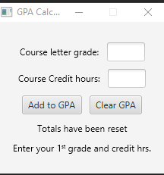}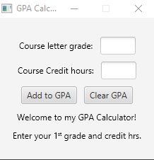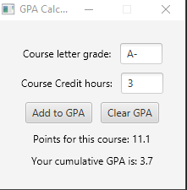

# Section B

3 classes

import java.text.DecimalFormat;

import java.text.NumberFormat;

import java.util.Locale;

public class ResortBooking {

String name;

TouristPackageBooking tTourist;

ElitePackageBooking eTourist;

NumberFormat cf = NumberFormat.getCurrencyInstance(Locale.CANADA);

ResortBooking(TouristPackageBooking touristIn, String name) {

tTourist = touristIn;

this.name = name;

}

ResortBooking(ElitePackageBooking touristIn, String name) {

eTourist = touristIn;

this.name = name;

}

String getBuildingNumber(TouristPackageBooking tourist) {

return "Building Number: " + tourist.getBuildingNumber();

}

String getBuildingNumber(ElitePackageBooking tourist) {

return "Building Number: " + tourist.getBuildingNumber();

}

String getTotalCost(TouristPackageBooking tourist) {

return "Total price for this package: " + cf.format(tourist.getTotalCost());

}

String getTotalCost(ElitePackageBooking tourist) {

return "Total price for this package: " + cf.format(tourist.getTotalCost());

}

}

public class TouristPackageBooking {

final double basePrice = 1475.00;

long aLaCarteMeals;

long spaVisits;

TouristPackageBooking(long aLaCarteMeals, long spaVisits) {

this.aLaCarteMeals = aLaCarteMeals;

this.spaVisits = spaVisits;

}

double getTotalCost() {

double spaVisitCosts = 0;

if (spaVisits == 1) {

spaVisitCosts = 125.00;

}

else if (spaVisits > 1) {

spaVisitCosts = 125 + ((spaVisits - 1) * 100);

}

return (basePrice + (aLaCarteMeals*35.00) + spaVisitCosts);

}

int getBuildingNumber() {

return (int)((Math.random() * (5-2) + 2));

}

}

public class ElitePackageBooking extends TouristPackageBooking{

ElitePackageBooking(long aLaCarteMeals, long spaVisits) {

super(aLaCarteMeals, spaVisits);

}

@Override

double getTotalCost() {

double aLaCarteMealsCost;

if (aLaCarteMeals <= 3) {

aLaCarteMealsCost = 0.00;

}

else {

aLaCarteMealsCost = (aLaCarteMeals -3) * 35.00;

}

return ((super.basePrice+775) + (aLaCarteMealsCost) + (spaVisits*75));

}

@Override

int getBuildingNumber() {

return 1;

}

}

Output

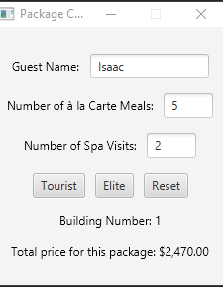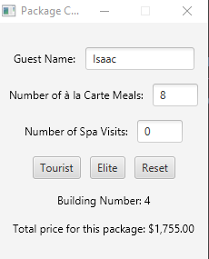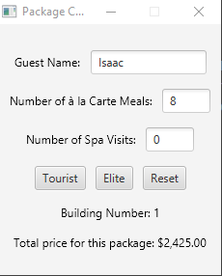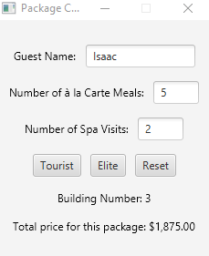

# Section C

Gui

import javafx.application.Application;

import javafx.event.ActionEvent;

import javafx.geometry.Insets;

import javafx.geometry.Pos;

import javafx.scene.Scene;

import javafx.scene.control.Button;

import javafx.scene.control.TextField;

import javafx.scene.layout.FlowPane;

import javafx.scene.text.Text;

import javafx.stage.Stage;

public class GUIFrontEnd extends Application {

FlowPane flowPane = new FlowPane();

Text textBuildingNumber = new Text("Welcome to Paradise Palms!");

Text textTotalCost = new Text("Enter your booking information.");

TextField textFieldName = new TextField("");

TextField textFieldALCM = new TextField("");

TextField textFieldNSV = new TextField("");

Text textName = new Text("Guest Name:");

Text textALCM = new Text("Number of \u00E0 la Carte Meals:");

Text textNSV = new Text("Number of Spa Visits:");

Button buttonTourist = new Button("Tourist");

Button buttonElite = new Button("Elite");

Button buttonReset = new Button("Reset");

public static void main(String[] args) {

launch(args);

}

@Override

public void start(Stage primaryStage) {

primaryStage.setTitle("Package Calculator");

flowPane.setPadding(new Insets(10, 10, 10, 10));

flowPane.setHgap(10);

flowPane.setVgap(15);

flowPane.setAlignment(Pos.CENTER);

buttonElite.setOnAction(this::calculateElite);

buttonTourist.setOnAction(this::calculateTourist);

buttonReset.setOnAction(this::reset);

textFieldName.setPrefWidth(120);

textFieldALCM.setPrefWidth(50);

textFieldNSV.setPrefWidth(50);

flowPane.getChildren().addAll(

textName, textFieldName,

textALCM, textFieldALCM,

textNSV, textFieldNSV,

buttonTourist, buttonElite, buttonReset,

textBuildingNumber,

textTotalCost);

primaryStage.setScene(new Scene(flowPane, 220, 250));

primaryStage.setResizable(false);

primaryStage.show();

}

private void calculateElite(ActionEvent actionEvent) {

ElitePackageBooking tourist = new ElitePackageBooking(Long.parseLong(textFieldALCM.getText()), Long.parseLong(textFieldNSV.getText()));

ResortBooking resort = new ResortBooking(tourist, textFieldName.getText());

textBuildingNumber.setText(resort.getBuildingNumber(tourist));

textTotalCost.setText(resort.getTotalCost(tourist));

}

private void calculateTourist(ActionEvent actionEvent) {

TouristPackageBooking tourist = new TouristPackageBooking(Long.parseLong(textFieldALCM.getText()), Long.parseLong(textFieldNSV.getText()));

ResortBooking resort = new ResortBooking(tourist, textFieldName.getText());

textBuildingNumber.setText(resort.getBuildingNumber(tourist));

textTotalCost.setText(resort.getTotalCost(tourist));

}

private void reset(ActionEvent actionEvent) {

textFieldName.setText("");

textFieldALCM.setText("");

textFieldNSV.setText("");

textBuildingNumber.setText("Welcome to Paradise Palms!");

textTotalCost.setText("Enter your booking information.");

}

}